
Jenkins Task -2
- Configure 2 slave machines in Jenkins master.
- Objective
- To configure two Jenkins slave (agent) machines and connect them to the Jenkins master using SSH, then verify by running jobs on the slaves
- Steps on Slave Machine-1 (slave-01)
- Steps to be done on slave
- Login to slave machine..
- switch to root user
- install jdk 11 (amazon-linux-extras install java-openjdk11)
- Create ssh-keygen
- cat id_rsa. pub › authorized_keys
- chmod 700 authorized keys
- Create EC2 Instance
- Name: slave-01
- OS: Amazon Linux 2023
- Allow SSH (22)
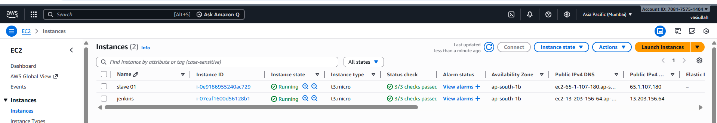
- Login & Switch to Root
- ssh -i key.pem ec2-user@ sudo -i
- Install Java
- dnf install -y java-17-amazon-corretto
- Verify: java -version

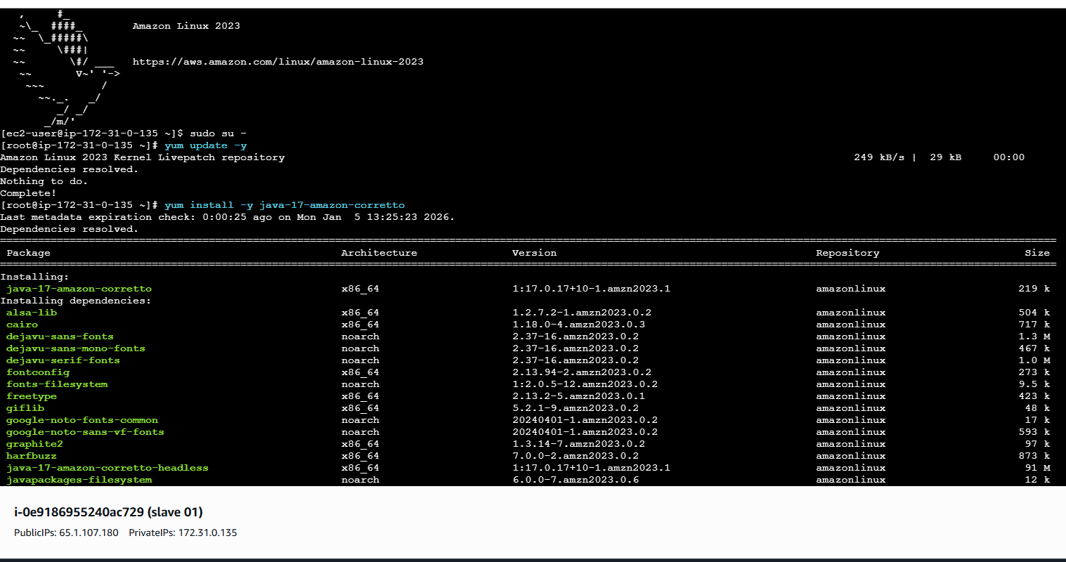
- ssh-keygen
- (Press Enter for all prompts)

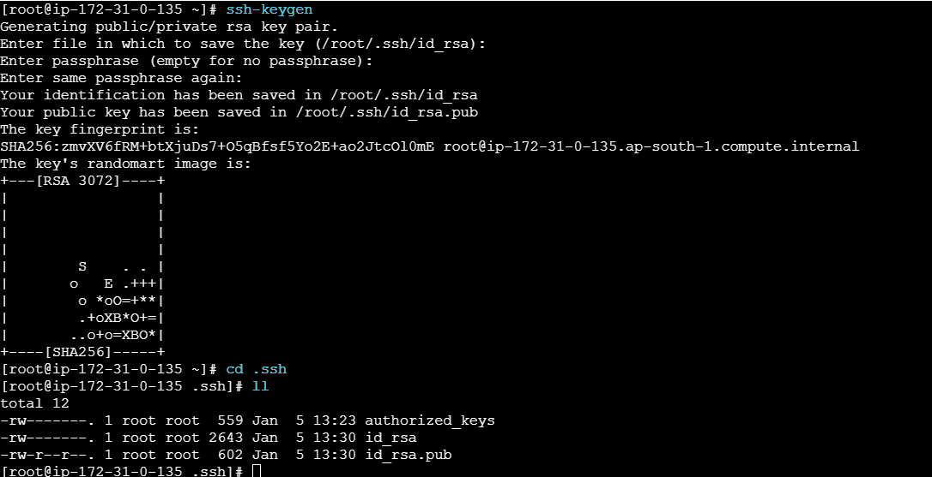

- cd ~/.ssh
- cat id_rsa.pub > authorized_keys
- chmod 700 authorized_keys

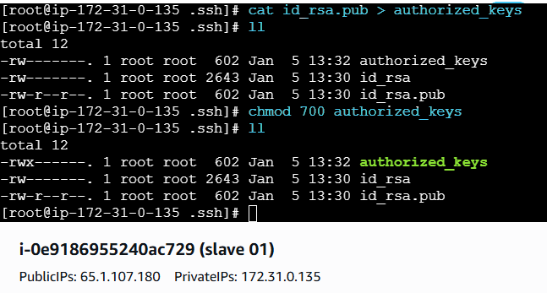
- Steps on Jenkins Master Machine
- Login to master machine
- switch to root user.
- mkdir -p /var/lib/jenkins/.ssh
- cd/var/lib/jenkins/.ss
ssh-keyscan -H 65.1.107.180 >> /var/lib/jenkins/.ssh/known_hosts
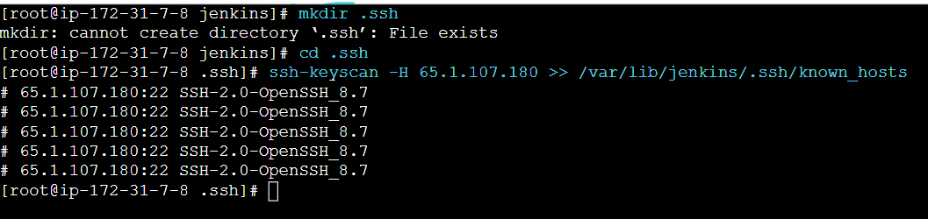
ssh-keyscan -H 65.1.107.180 >> /var/lib/jenkins/.ssh/ known_hosts
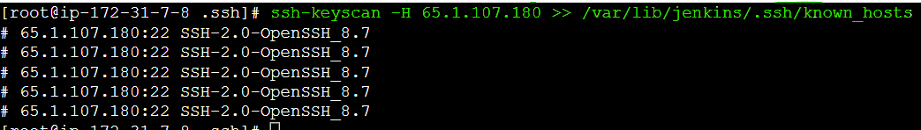
Permissions
- chown jenkins:jenkins known_hosts
- chmod 700 known_hosts

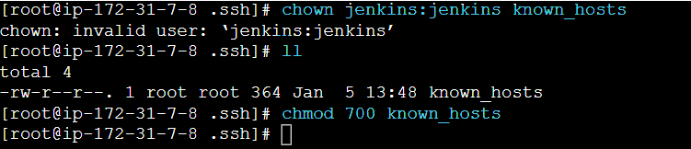
- Create New Node
• Go to: Manage Jenkins → Manage Nodes and Clouds
• Click New Node
• Node Name: slave-01
• Type: Permanent Agent
• Click OK

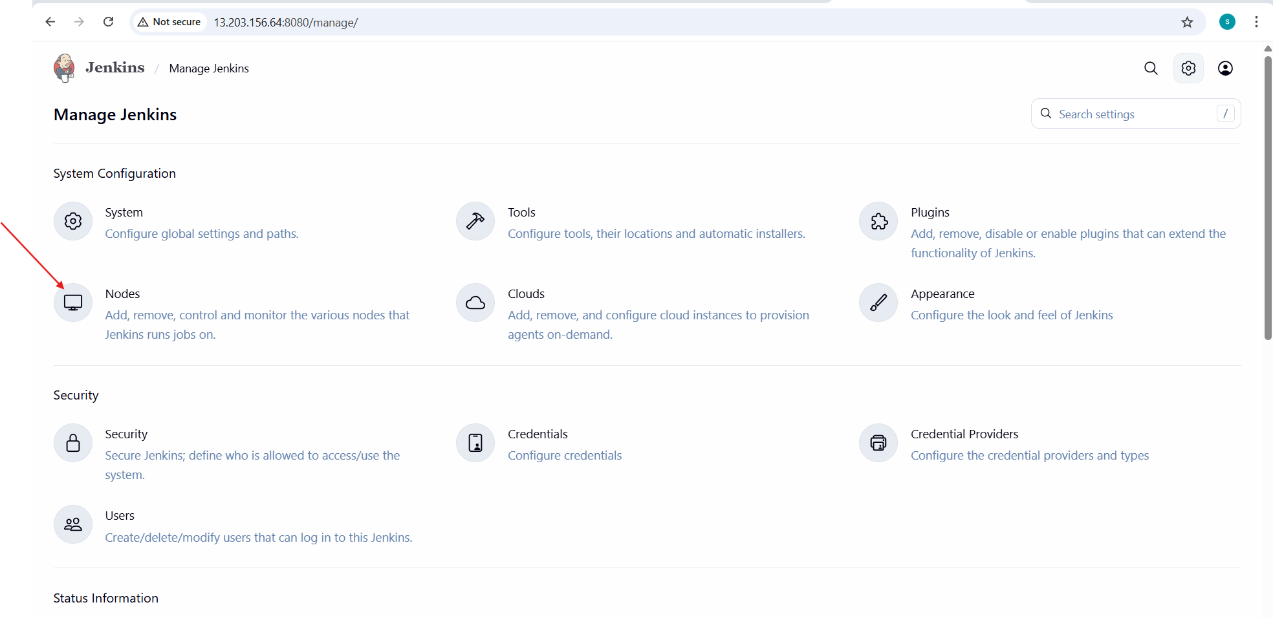

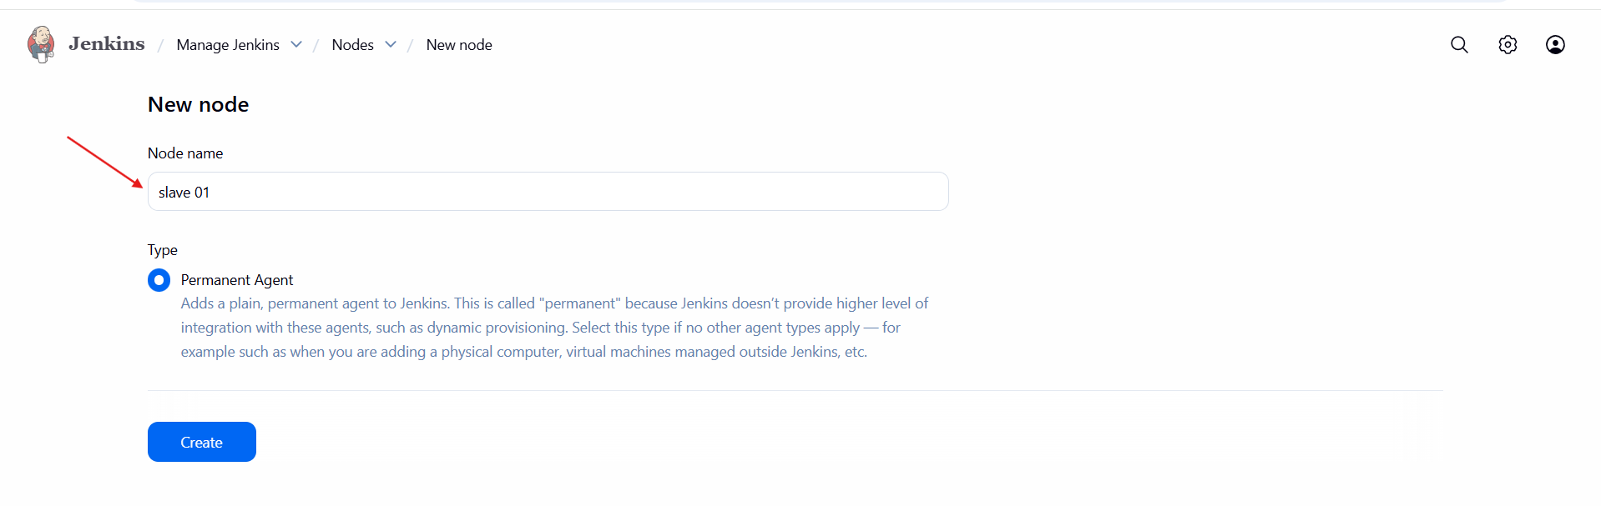
Configure Node
• Remote root directory: /home/ec2-user
• Labels: java
• Launch method: Launch agent via SSH
• Host:slave public ip
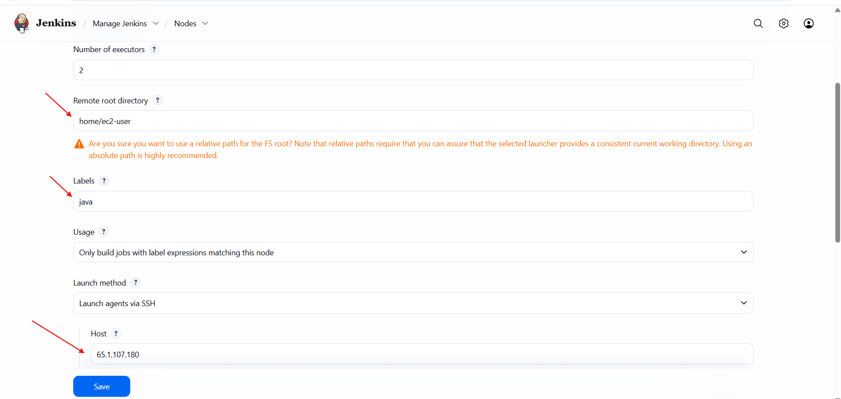
Add Credentials
• Click Add → Jenkins
• Kind: SSH Username with private key
• Username: ec2-user
• Private Key: Paste AWS .pem file content
• Save

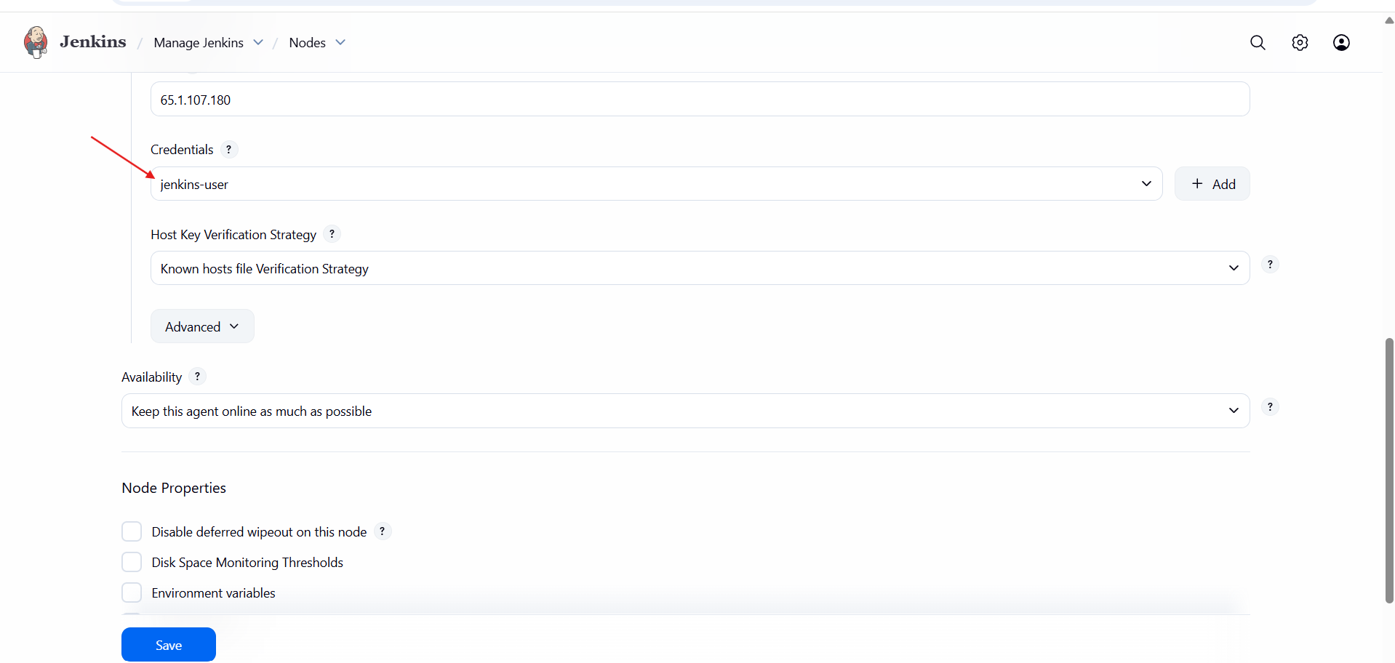

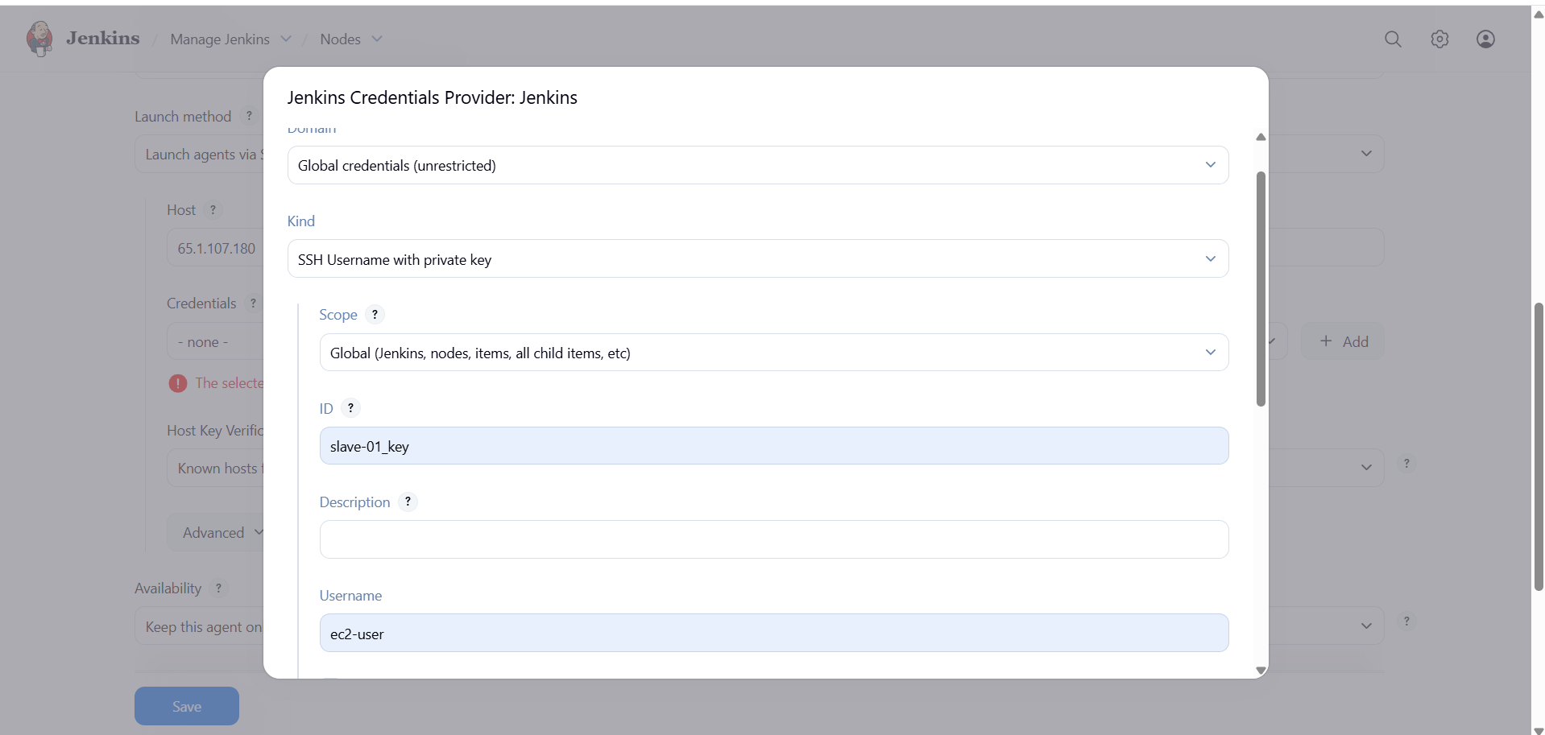

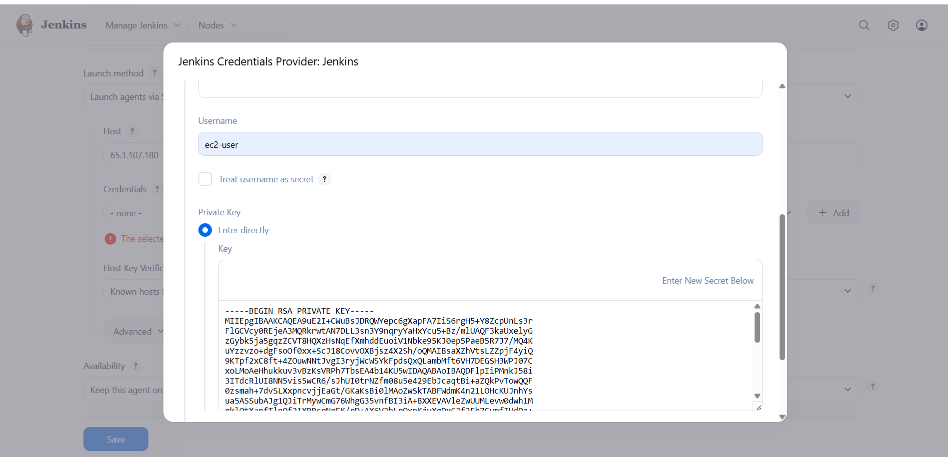
Save & Test
• Click Save
• Jenkins should connect to slave via SSH
• Node status → Online

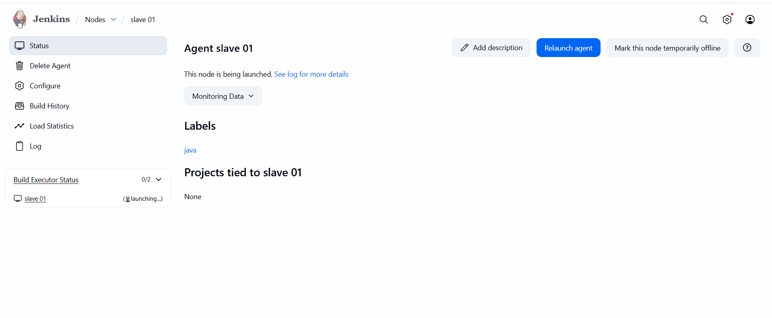
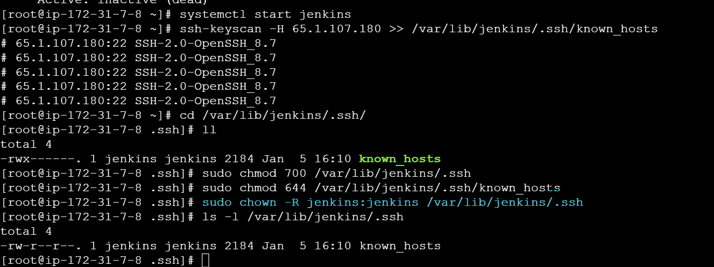

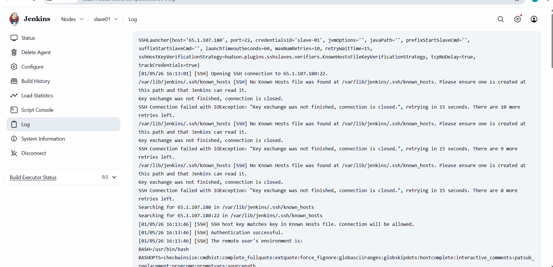
- check logs for conformation
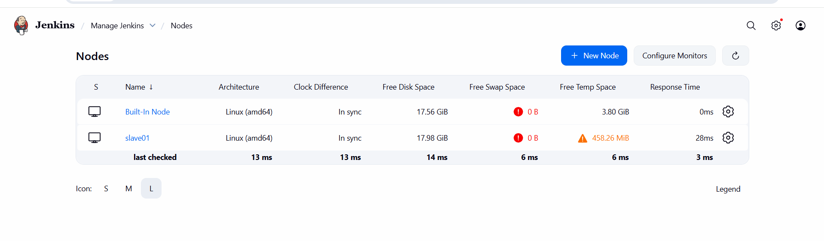
Create Freestyle Job
• Jenkins → New Item
• Job Name: Job-slave1
• Select Freestyle Project
• Click OK
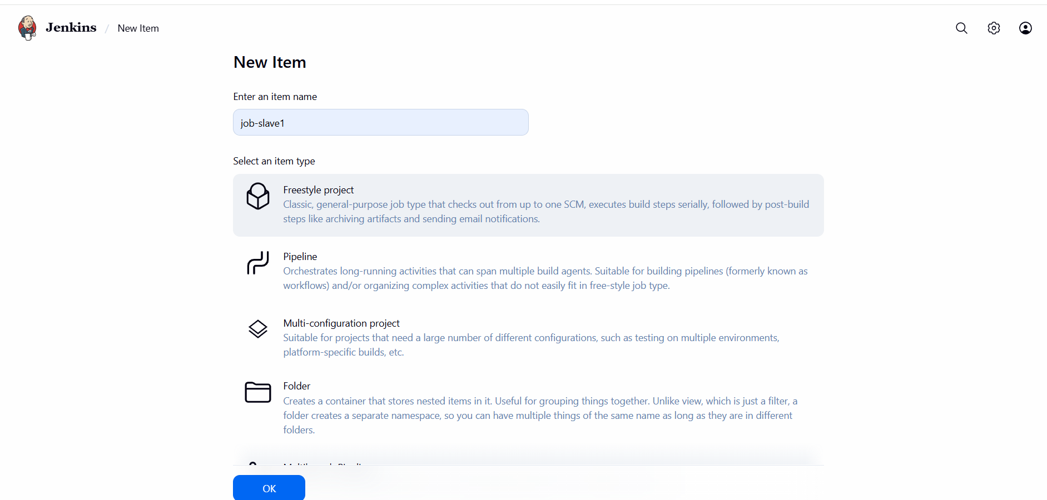
Restrict Job to Slave
• Job Configuration → General
• Check Restrict where this project can be run
• Label Expression:java
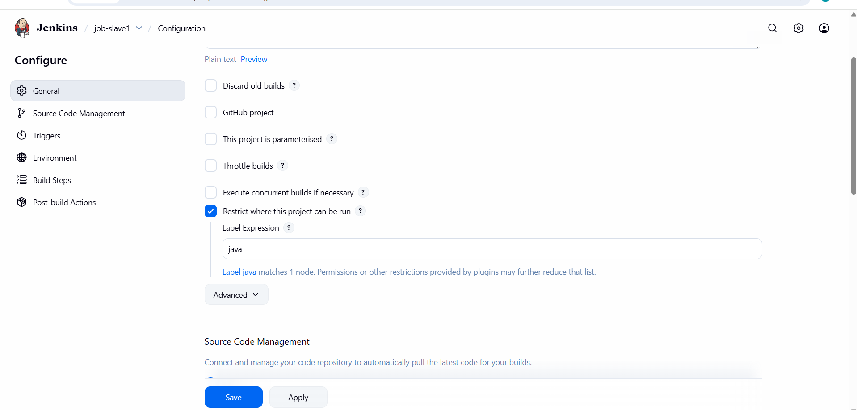
Build
• Save
• Click Build Now
• Build runs only on slave-01
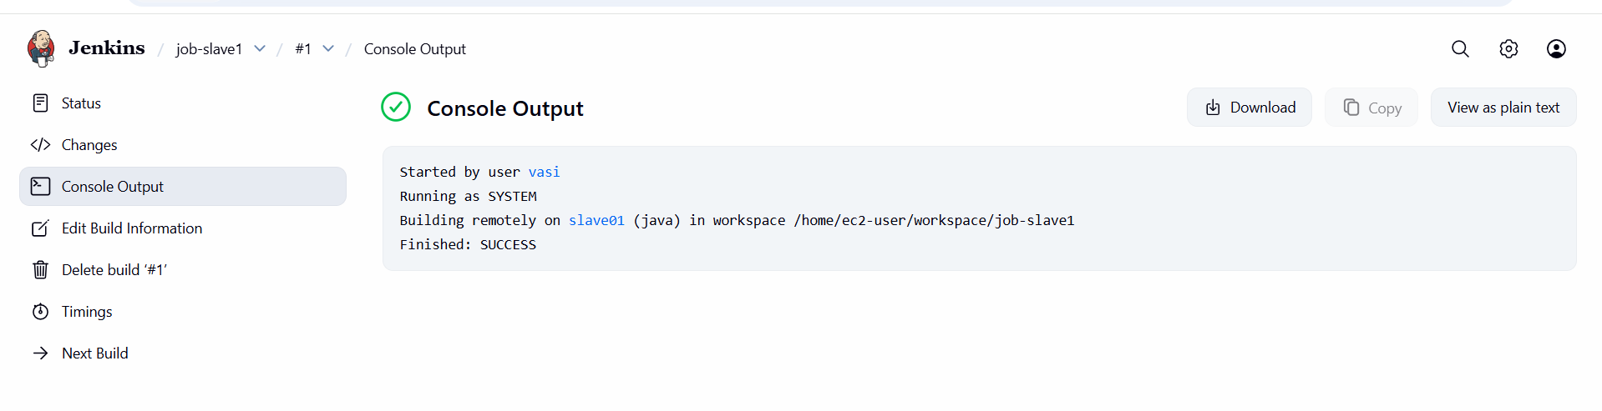
- Jobs successfully executed on specific slaves using labels
- Configure webhooks to Jenkins job.
Configure GitHub Webhook
—> Configure GitHub Webhook
• Go to your GitHub repository → settings → Webhooks → Add webhook.
• In the Payload URL, enter:
• http://13.201.190.87:8081/github-webhook/
• Click Add webhook.
• Choose Send me everything.
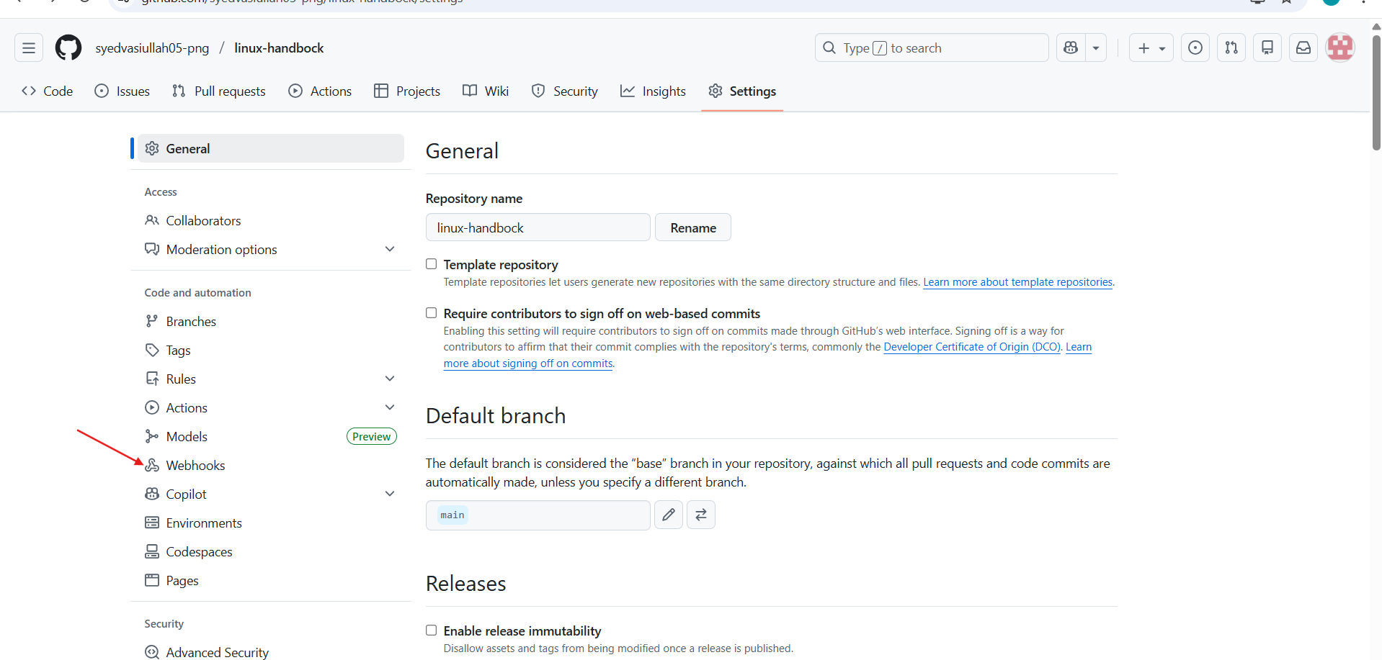

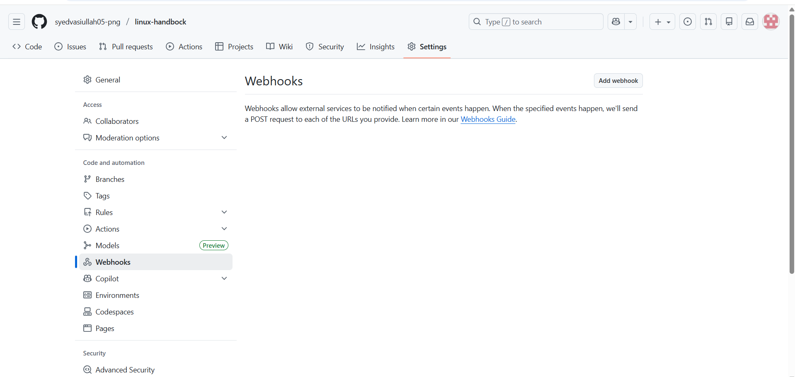
- In the Payload URL, enter:
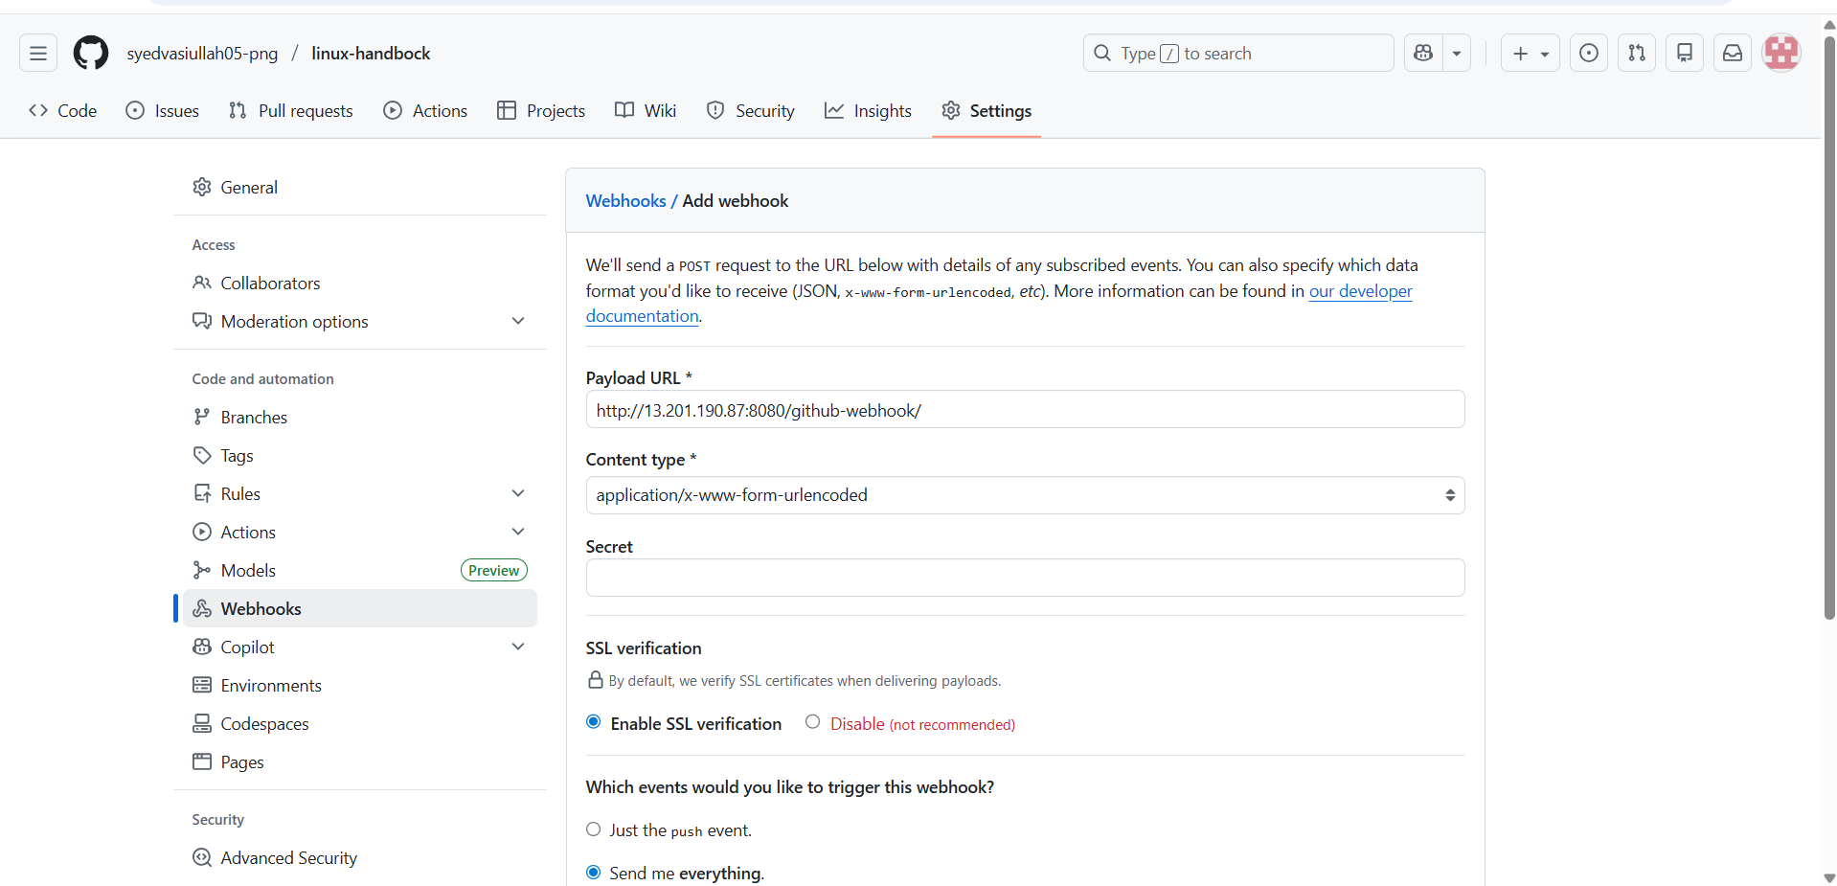
• http://13.201.190.87:8080/github-webhook/
• Click Add webhook.
• Choose Send me everything.
- successfully created the webhook

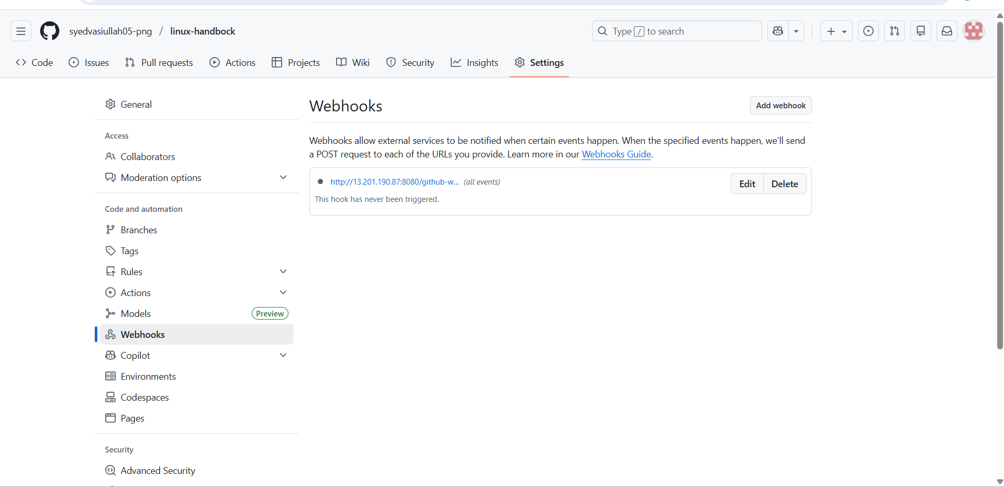
- Create / Configure Jenkins Job
- Create a Freestyle Project –(webhook-job)
- Under Source Code Management, choose Git and add your repository URL.
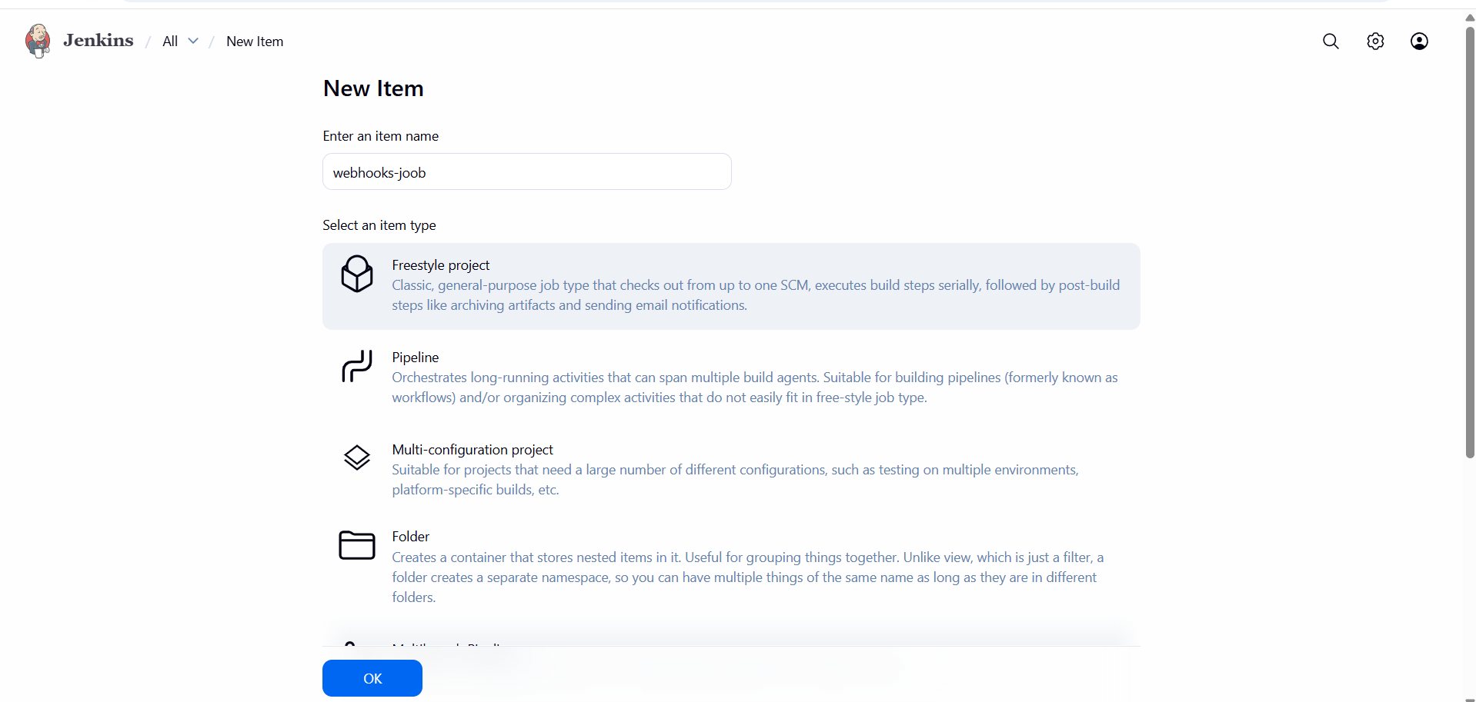
- Under Source Code Management, choose Git and add your repository URL.
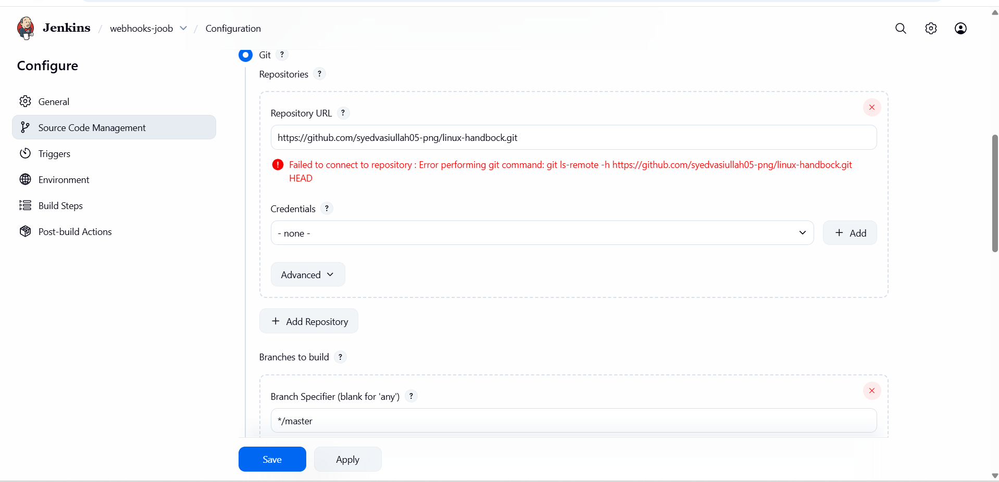
- Enable Build Trigger
• In your Jenkins job → Configure → Scroll to Build Triggers
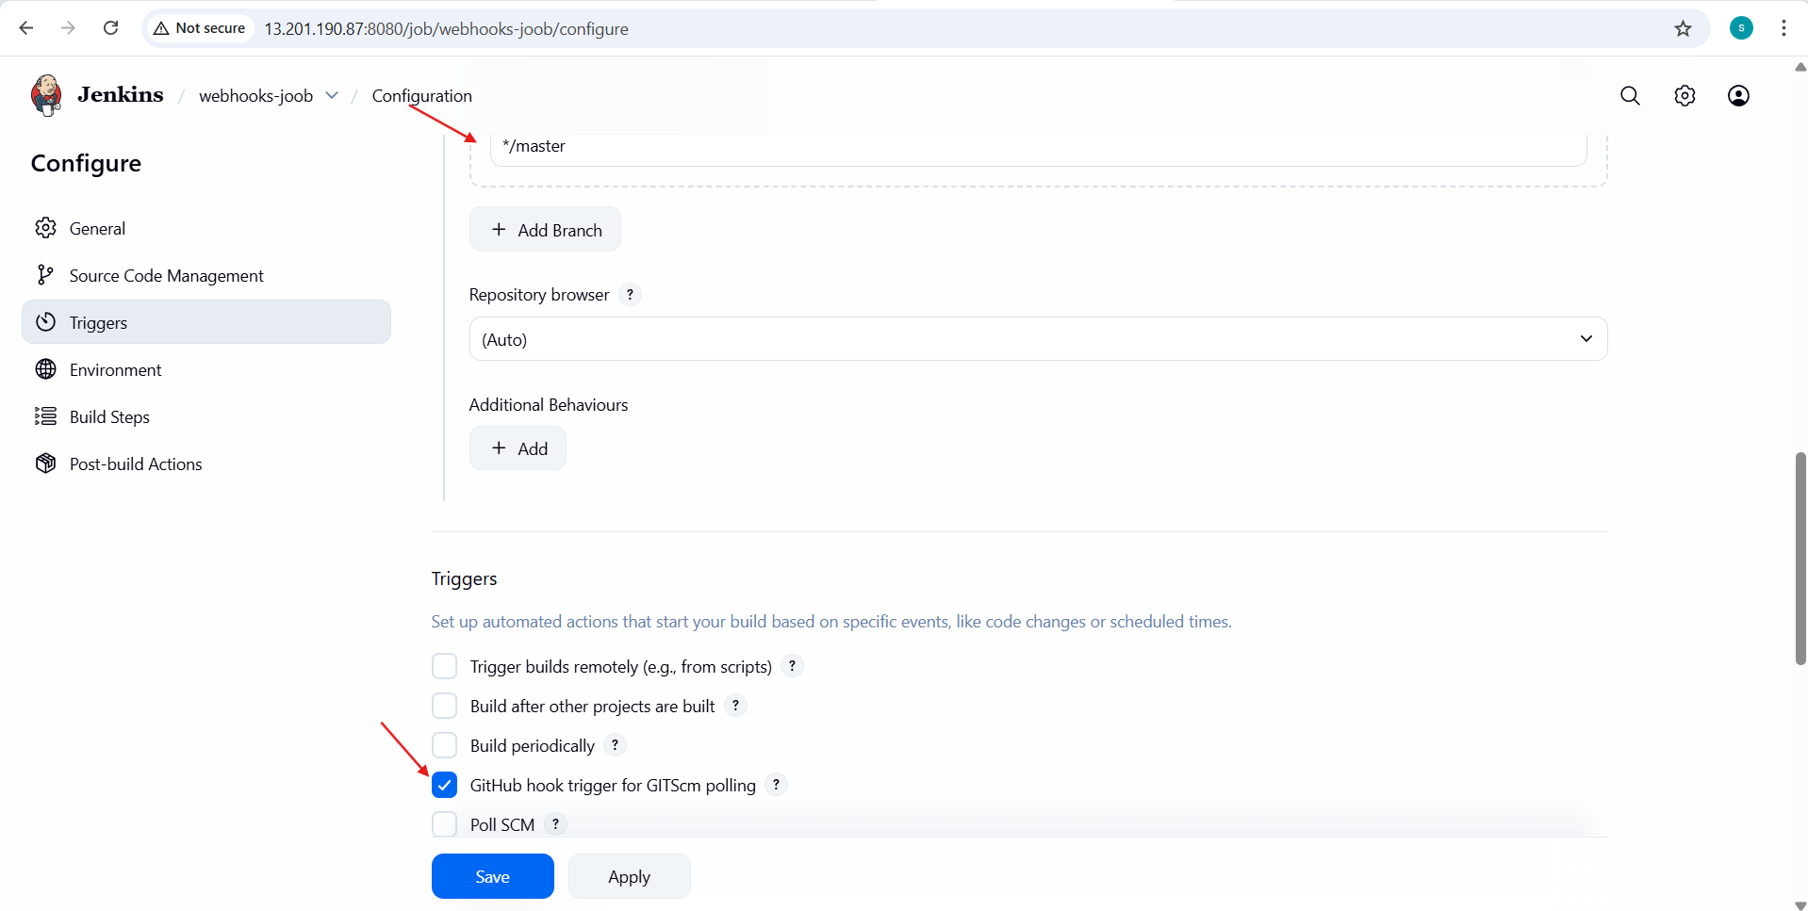
- edited the readme.md file and commit the change
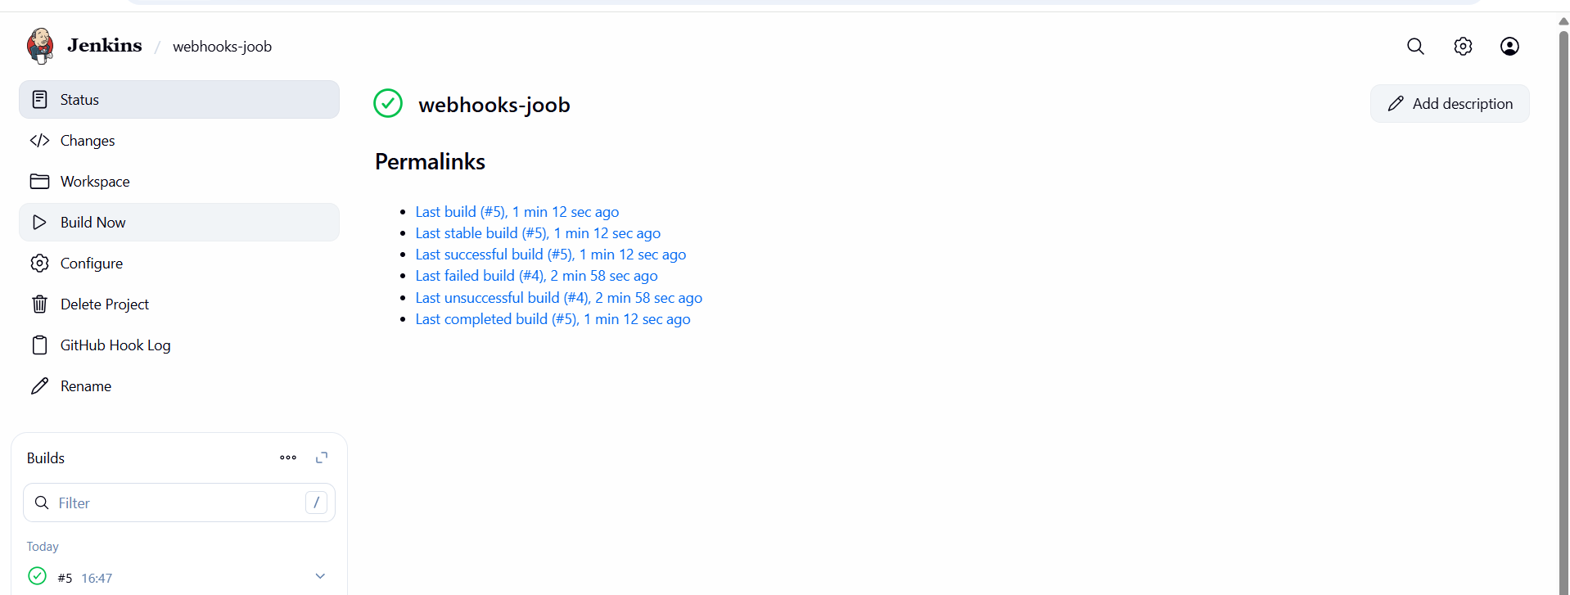
- we are able to get the build now automatically
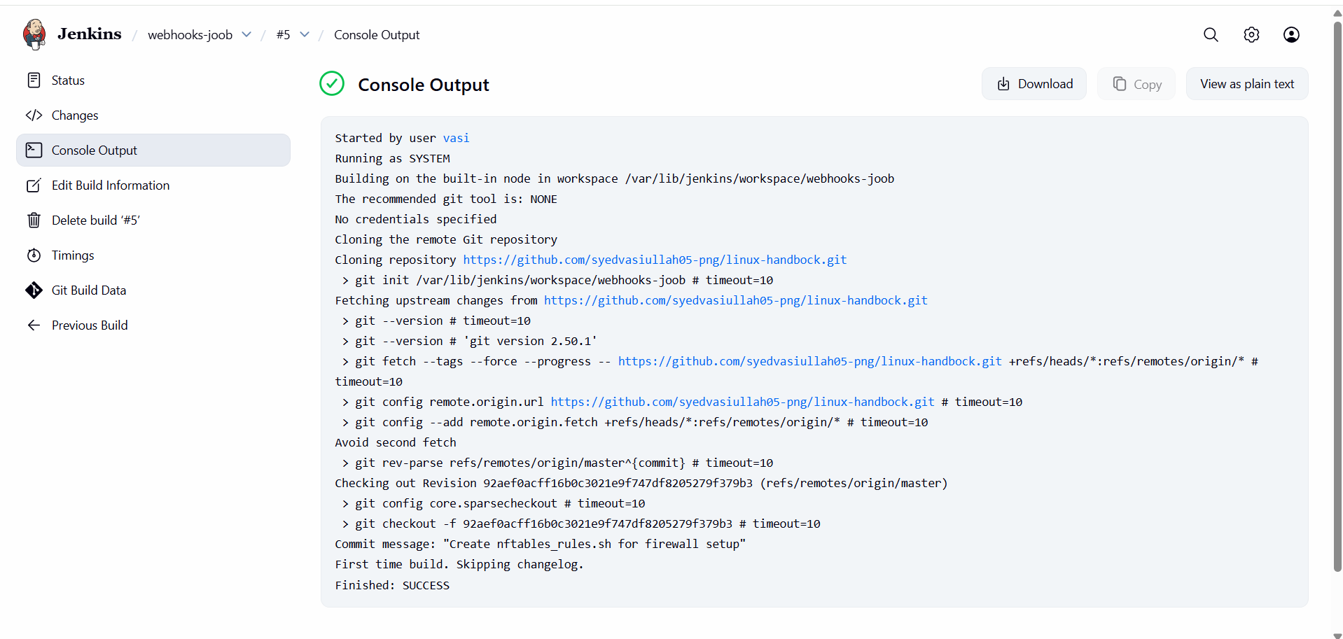
- Configure poll scm and build periodical options in Jenkins job.
- Poll SCM
This op on tells Jenkins to check the source code repository (Git, SVN, etc.) at defined intervals. If it detects any change (new commit), it triggers a build.
• Go to your Jenkins job → Configure.
• Scroll down to Build Triggers.
• Check Poll SCM.
• In the Schedule box, use cron-style syntax:

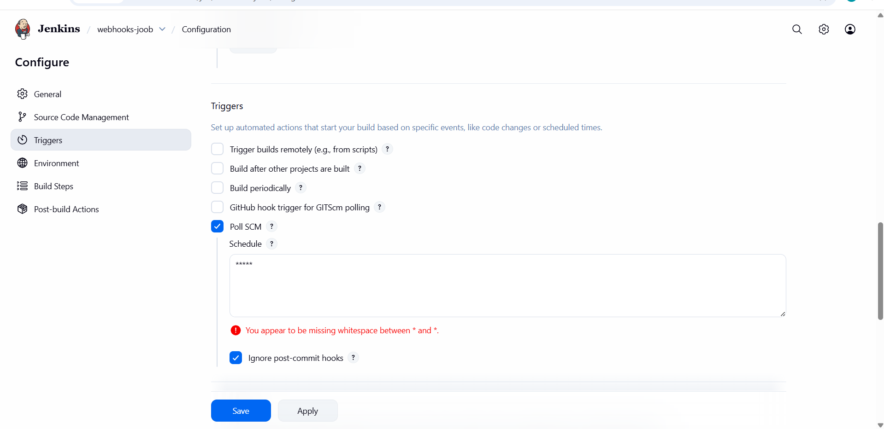
- went to GitHub repo and commit changes
- we will be getting the trigger build now
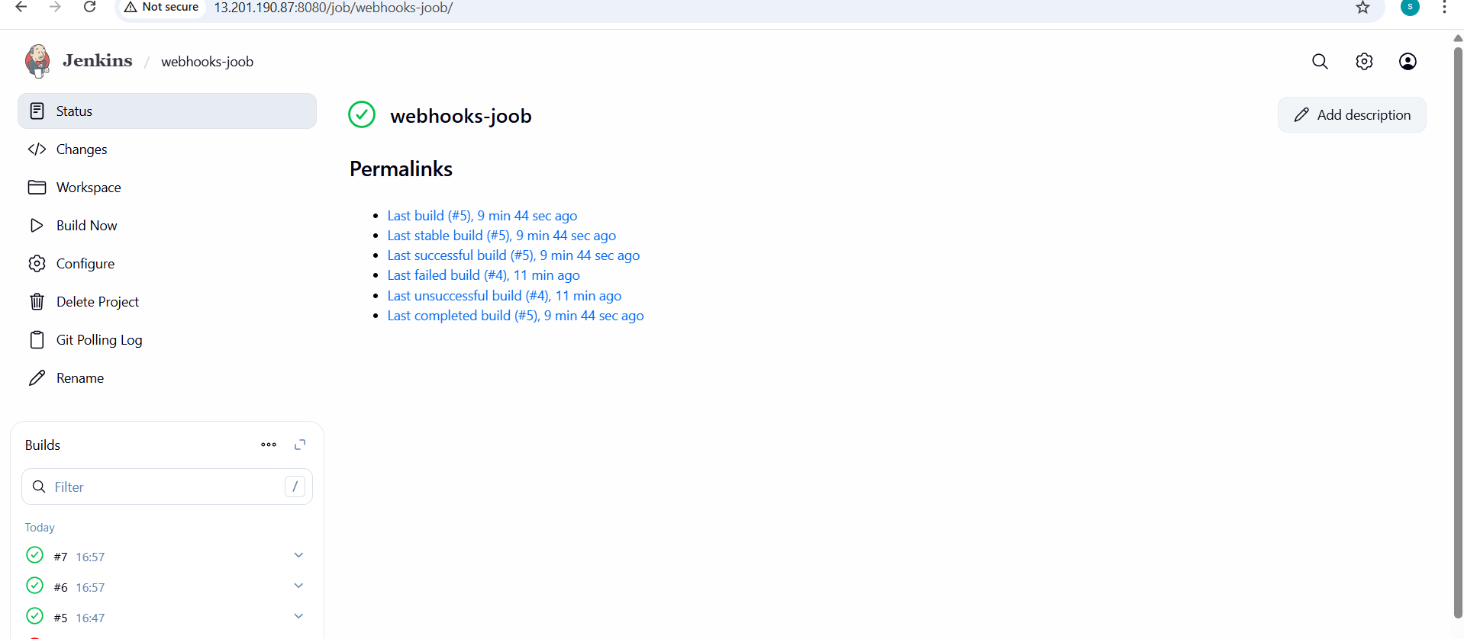
- Build periodical
This op on triggers builds whether or not there are Source Code Management ( scm) changes.
• Go to your Jenkins job → Configure.
• Scroll down to Build Triggers.

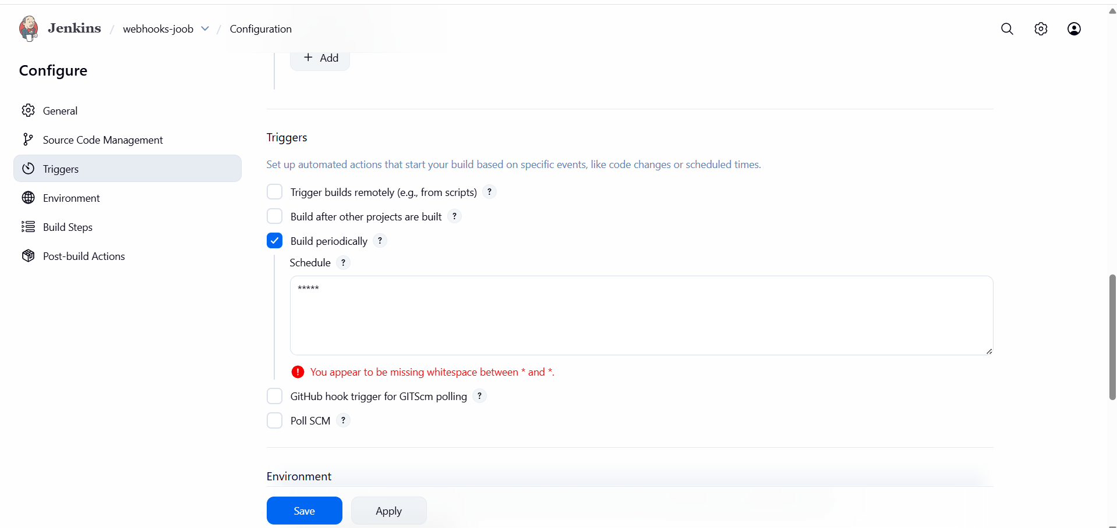
- Check Build periodically.
- Enter a cron-style schedule in the Schedule box:
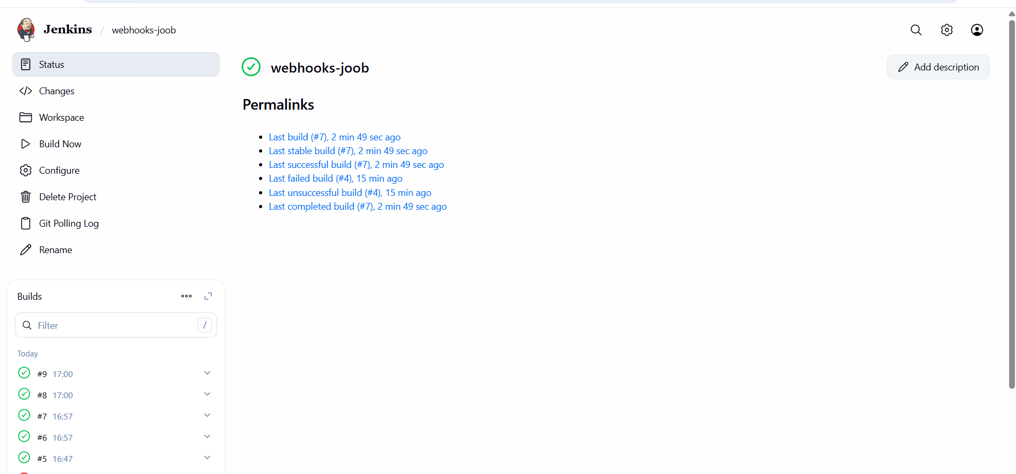
- we are able to trigger the build now of the job based on build periodical and poll scm

- Take backup of Jenkins server by using bash script.
- Objective
- To take a manual backup of Jenkins server using a Bash script by backing up Jenkins home directory
- Jenkins stores all important data in: /var/lib/jenkins This includes:
- Jobs
- Plugins
- Configurations
- Credentials
- Build history
- Below script is used for creating the backup of the Jenkins server
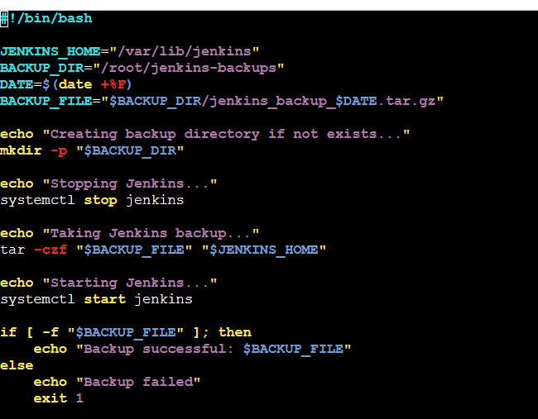
- Run Backup Script
- vi backup.sh
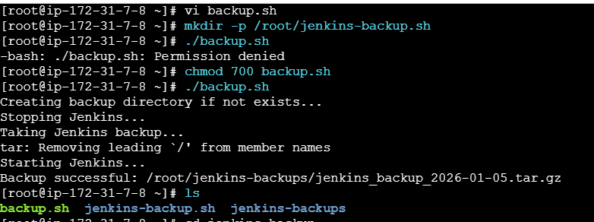
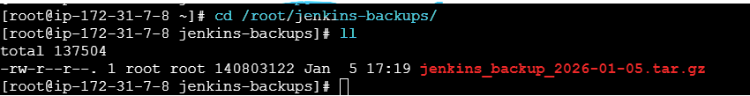
- successfully created the backup of the Jenkins server by using the bash script

- Take backup of Jenkins using rethin backup plugin.
Objective
To take a Jenkins backup using the ThinBackup plugin, which provides an easy and automated way to back up Jenkins configuration, jobs, and plugins.
Steps on Jenkins GUI
- Install ThinBackup Plugin
- Login to Jenkins Dashboard
- Go to Manage Jenkins → Manage Plugins
- Click on Available Plugins
- Search for ThinBackup
- Select ThinBackup
- Click Install
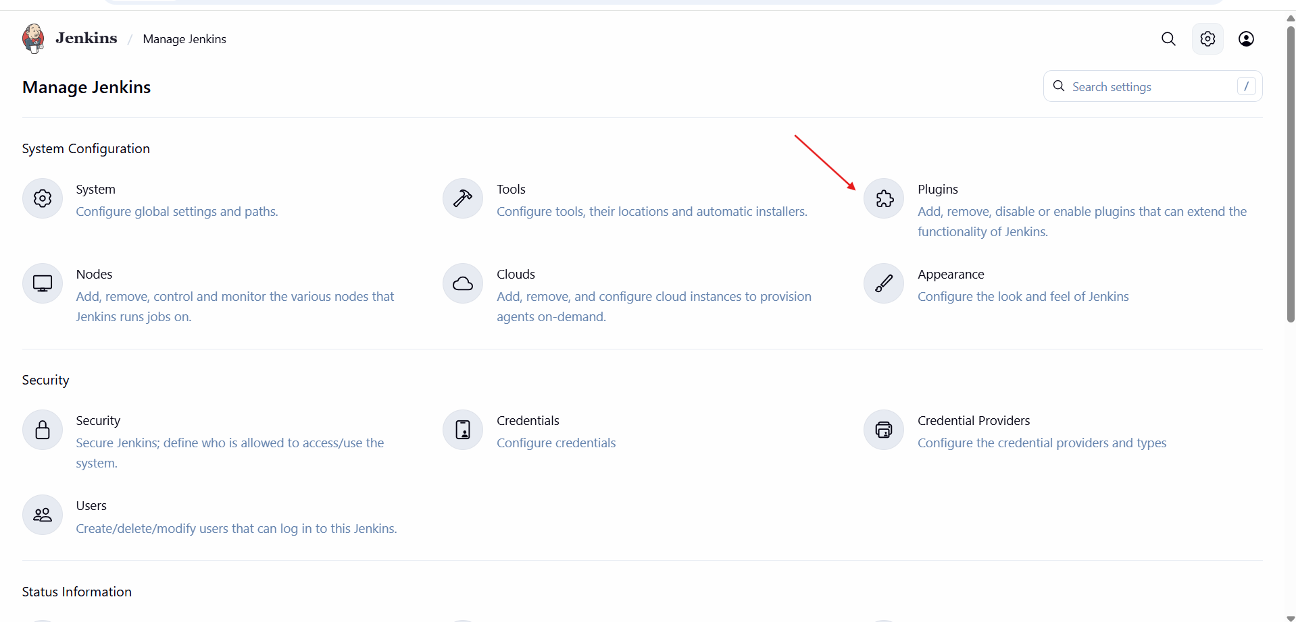
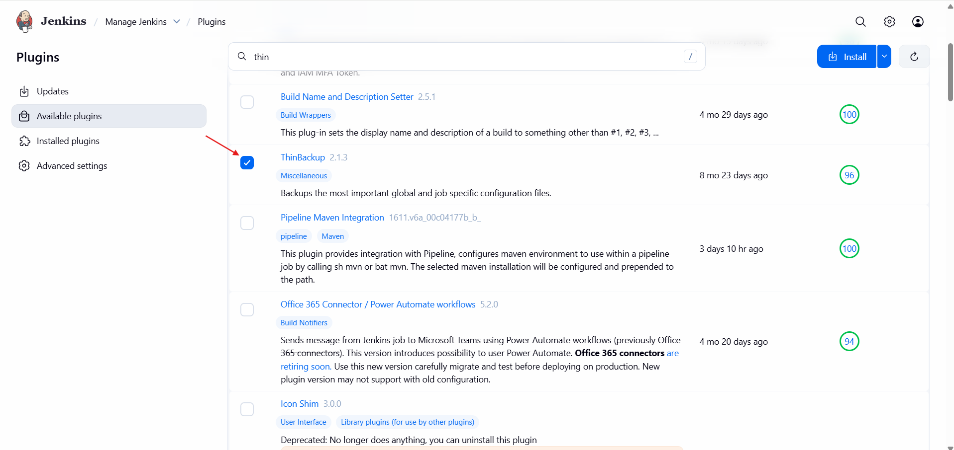
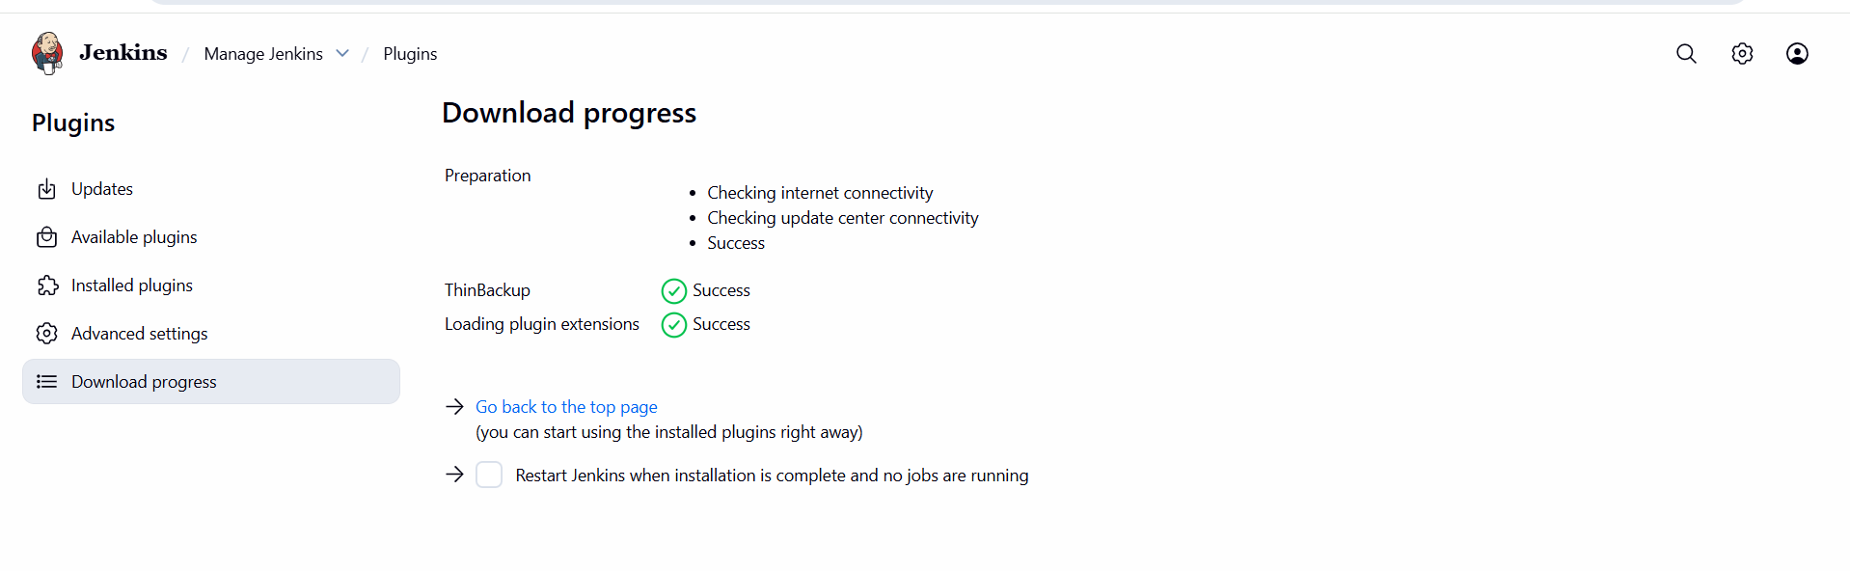
- thin backup successfully installed
- Configure ThinBackup
- Go to Manage Jenkins → ThinBackup
- Click Settings
- Configure the following:
- Backup Directory
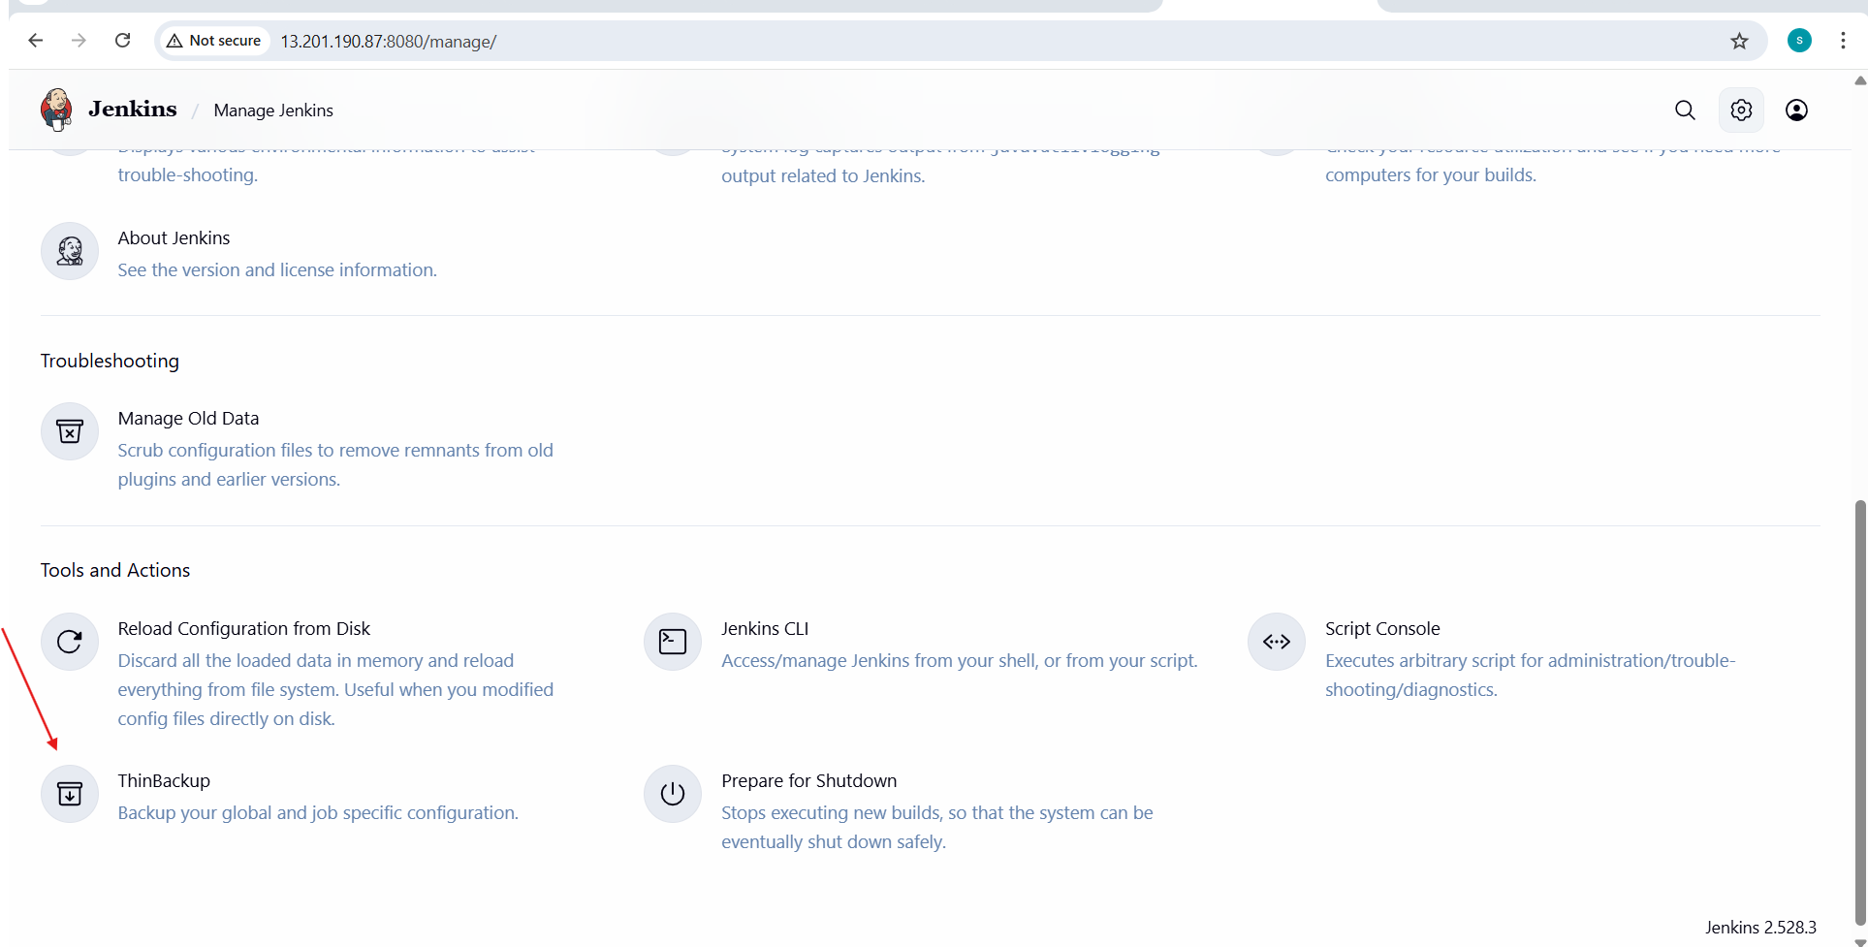
- Backup directory: Path where backups will be stored (e.g., /var/Jenkins-backup).
- Click Save.
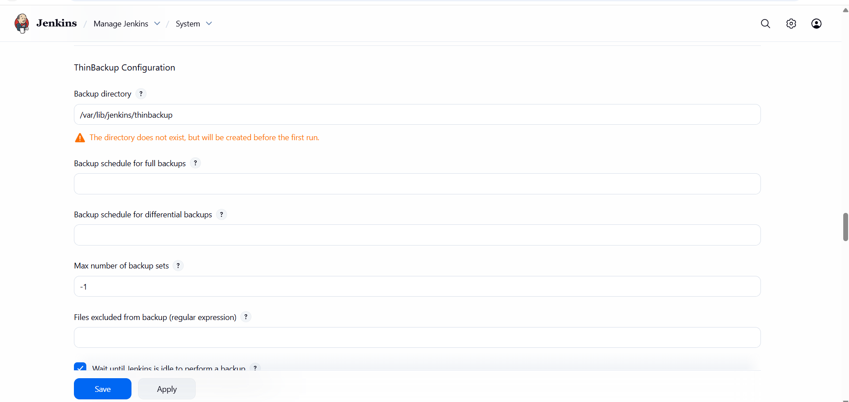
- Take Manual Backup
- Go to Manage Jenkins → Thin Backup.
- Click Backup Now.
- The backup will be created in the folder you configured (/var/Jenkins/backups-22).
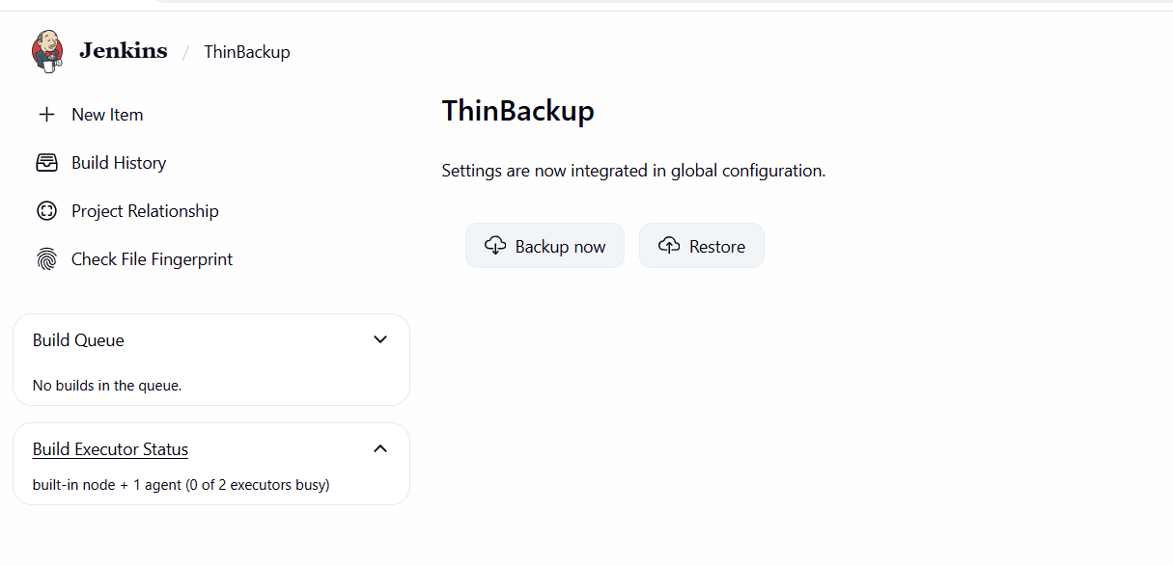
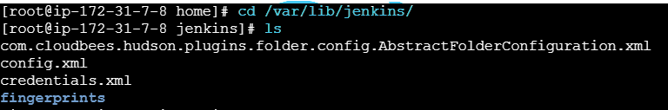
- Verify Backup
- Navigate to the backup folder
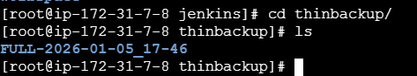

- Setup a new Jenkins server and dump the backup taken in task4.
- Objective
To set up a new Jenkins server and restore Jenkins data using the bash backup (tar.gz) taken in Task-4
- What we already have From Task-4,
you have a backup file like:
jenkins_backup_2026-01-05tar.gz
Stored in: /root/jenkins-backups/
This backup contains: /var/lib/jenkins
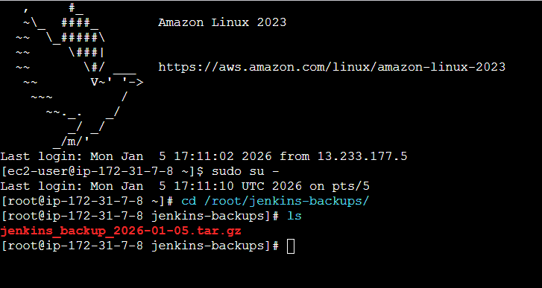
- Launch a new EC2 instance
- OS: Amazon Linux
- Open ports:
- 22 (SSH)
- 8080 (Jenkins)

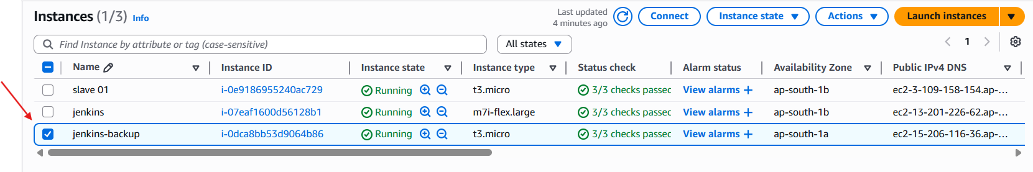
- yum install -y java-17-amazon-corretto
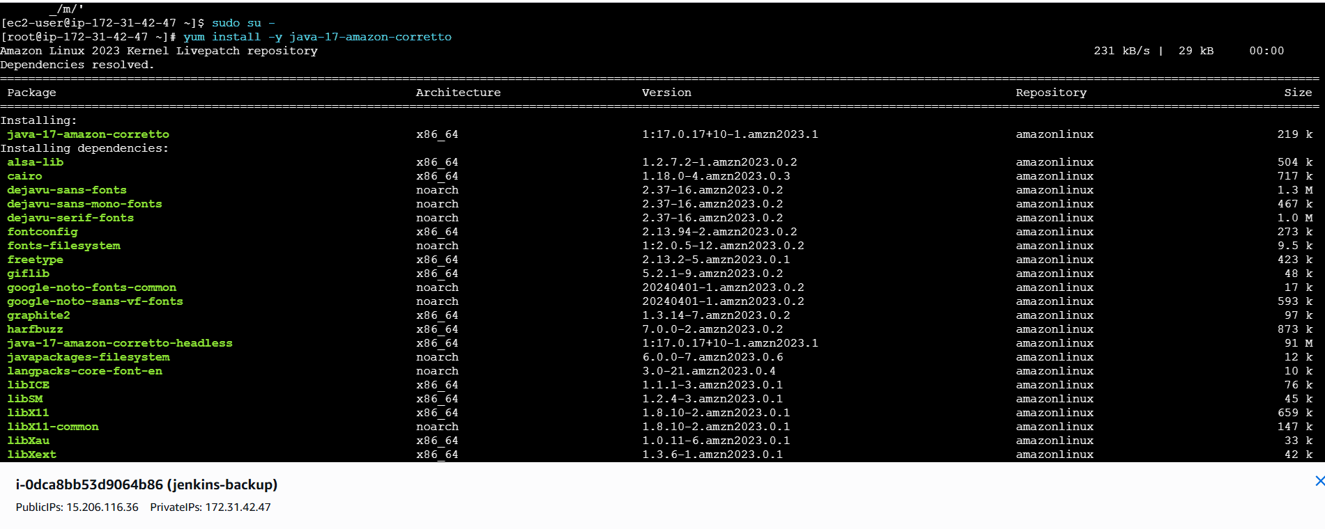
sudo wget -O /etc/yum.repos.d/jenkins.repo h ps://pkg.jenkins.io/redhat-stable/jenkins.repo

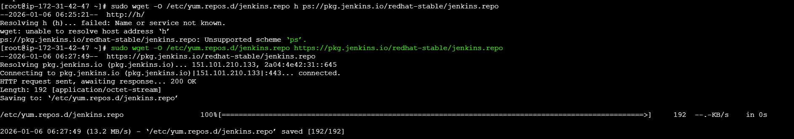
- rpm --import https://pkg.jenkins.io/redhat-stable/jenkins.io-2023.key
- Install Jenkins
- sudo yum install jenkins –y
- systemctl enable Jenkins
- systemctl start Jenkins
- systemctl status jenkins

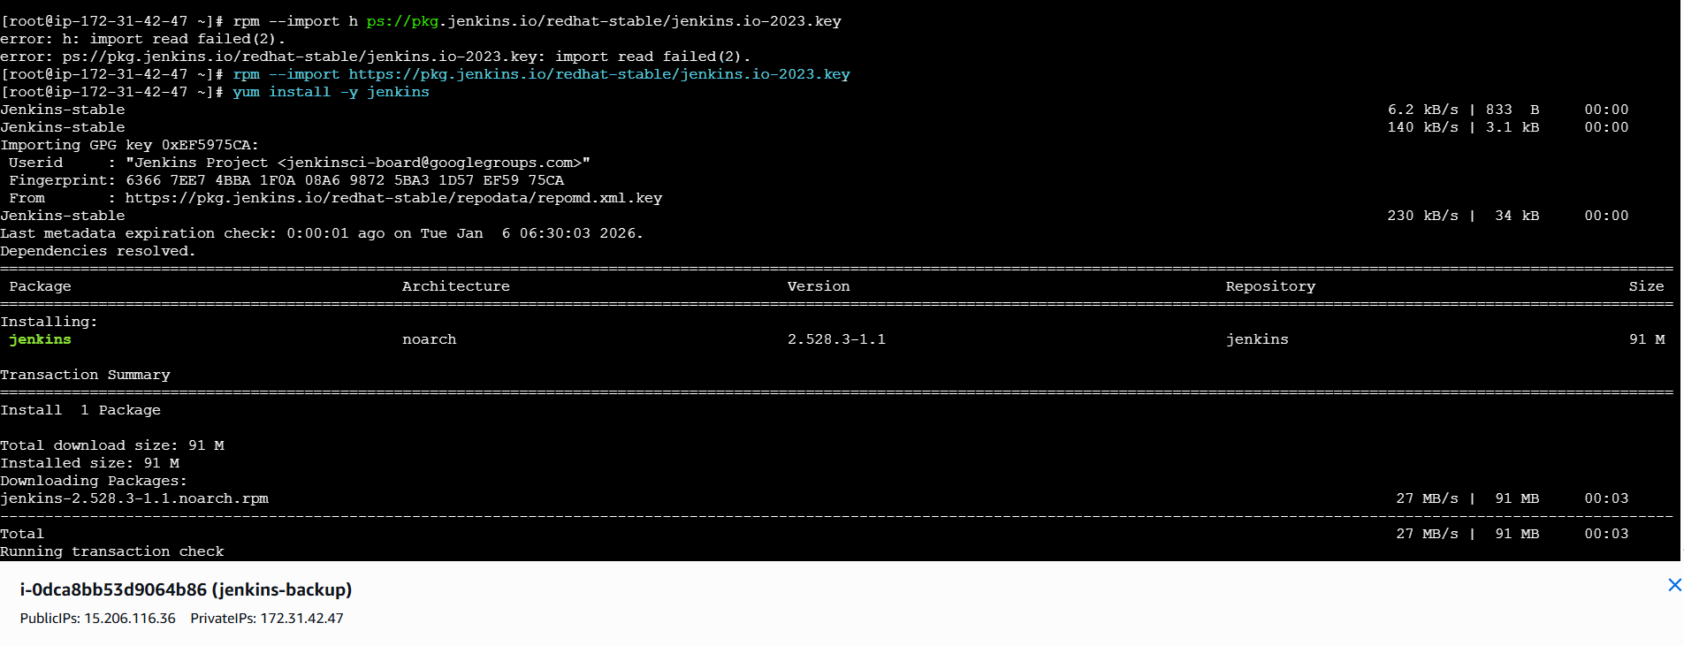
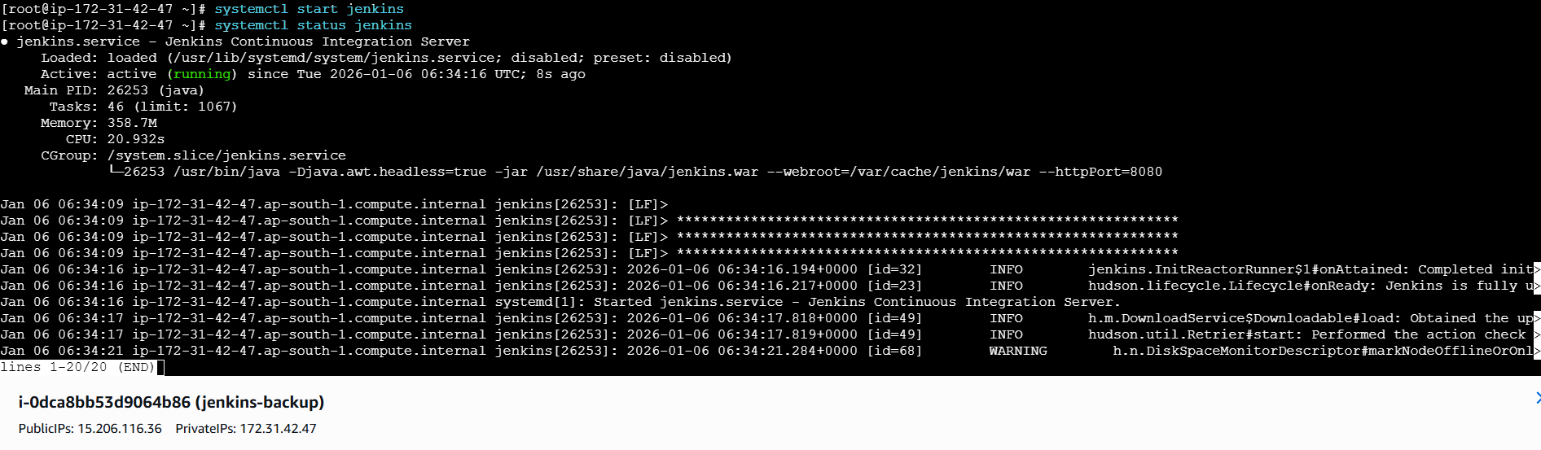
- Now open your master server of Jenkins
- Login into your old main server you took backup Create an test.pem file where you copy your pemkey of new-server and and paste in the oldserver
- scp test.pem/root/jenkins-backups/jenkins_backup_2025-12-24.tar.gz \ ec2-user@:/tmp
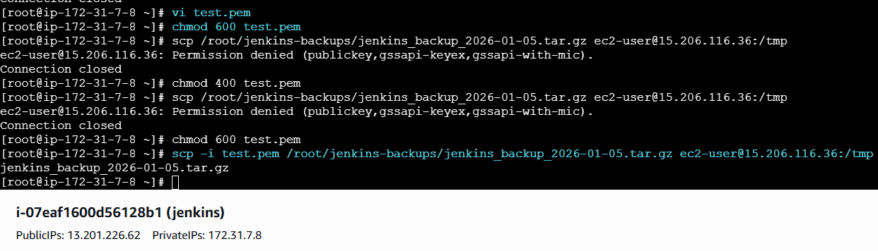
- Login in to new server and check the file in /tmp
- jenkins_backup_2026-01-05.tar.gz —> is backup file

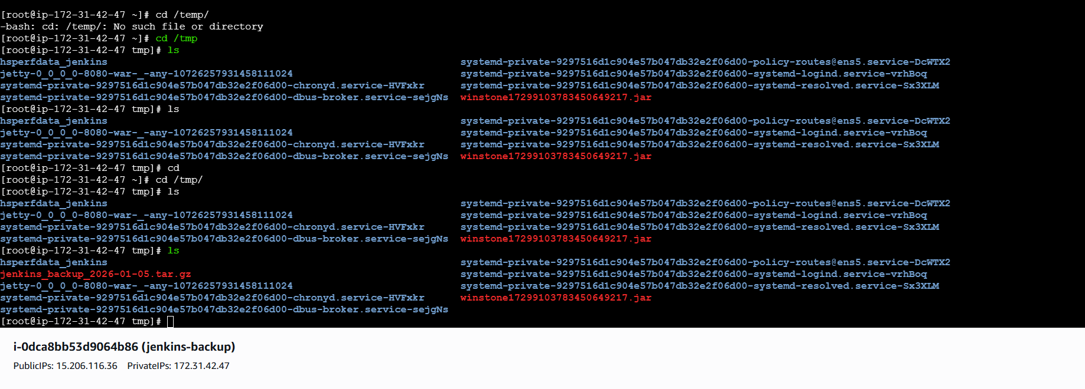
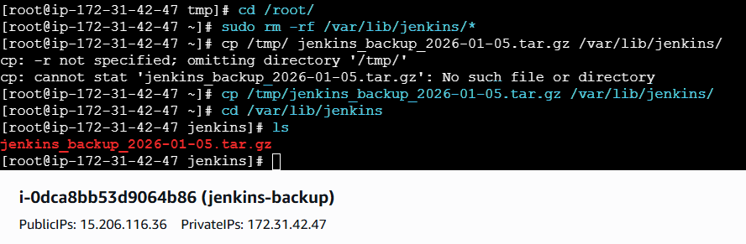
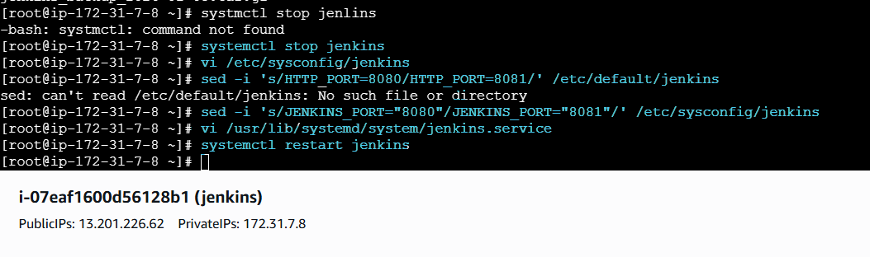
- Below is the new server we are able to see the back up from master Jenkins
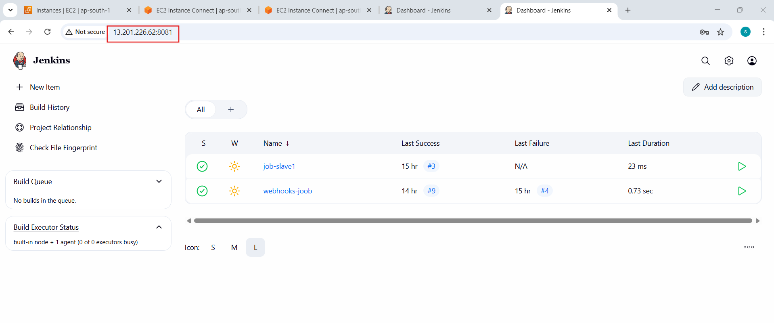
- Below is the master Jenkins we are able to see same data in Jenkins- backup and master Jenkins
